Horse GPS Tracking Systems
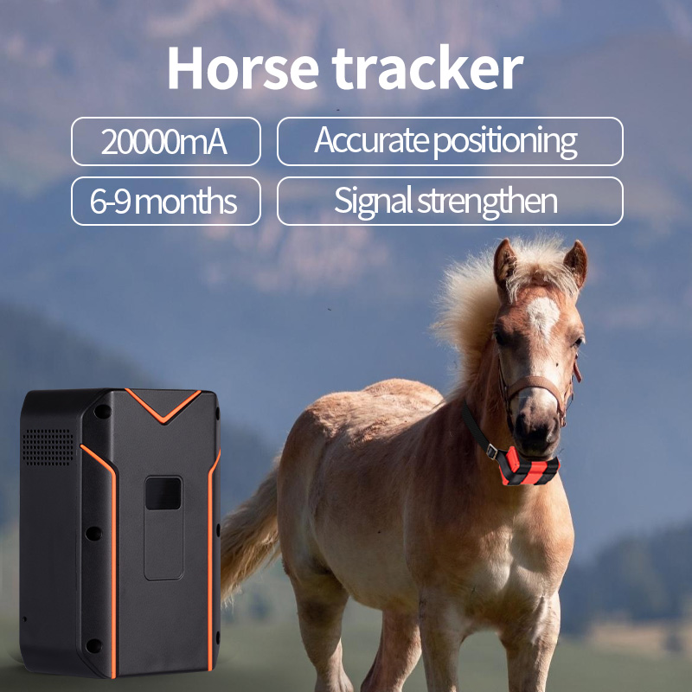
Price：$82.6
Product model：S10
Product parameter：
Positioning technologies | GPS+BDS+WIFI+LBS+AGPS
Positioning accuracy | satellite position 5-15 meters
Base station positioning | 50-1000 meters
Size | 106*71*45mm
Battery | 20000mAh
Weight | 412g
Super long standby time | 5-6months
Product feature：
• Long-Lasting Power: The device features a 20,000mAh battery, offering a standby time of 5-6 months and a working time of 6-9 months. This is ideal for long-term use without constant recharging.
• Accurate Positioning: Uses a combination of technologies including GPS, BDS, WIFI, LBS, and AGPS for precise and reliable tracking.
• Voice Intercom: This feature allows for two-way voice communication, which can be useful for remote monitoring or directing a handler.
• Intelligent Power Saving: The device is designed to optimize battery usage, extending its operational life.
• Durable Design: The tracker is built to be robust, suitable for livestock and horses.
• Compact Size: With dimensions of 106*71*45mm and a weight of 412g, it's a manageable size for a horse to wear comfortably.
Product function：
• Real-Time Tracking: Provides continuous, live location data of the horse.
• Historical Trajectory: Allows users to view and analyze the horse's past movements and routes.
• Geo-Fencing: You can set up a virtual boundary and receive alerts if the horse leaves or enters a specific area.
• Built-in Satellite Map: The tracking data is displayed on a built-in satellite map for a clear visual representation.

